Test Project

Module 03 – Layout(HTML&CSS)

WSA2021_TP17_Module03

Submitted by

**Name: Oscar Fernando Aristizábal Cardona**

**Country**: CO

**INTRODUCTION**

«Petfinder» is an organization in Guatemala that is responsible for collecting abandoned pets, mostly dogs and cats, «Petfinder» is responsible for giving them a new temporary home with all the comforts such as shelter, food and veterinary care, this organization requires front-end developer services to build a mobile application where people can find and adopt these pets.

The design of the mobile application has already been developed by the design team; it has already been approved by the managers. All design files that include images, typography and colors will be provided to perform this task. It is intended that the final layout in HTML, CSS is identical or as faithful as possible to the design provided. The use of Javascript is not allowed. Any Javascript code will be excluded during the evaluation process.

The layout must be developed only for a maximum resolution of 414 pixels wide by a minimum of 800 pixels high, the content must be presented centered both vertically and horizontally.

**PROJECT DESCRIPTION TEST**

This task will be completed in 2.5 hours. The result should work in modern browsers and will be tested in google chrome. You should pay close attention to the details, size and weight of the texts, horizontal and vertical distances between elements, events and transitions, additionally all texts must be selectable.

The organization understands that this is a voluminous task to be completed in 2.5 hours, so a video will be provided with the functional prototype of said application.

**Glossary**

* **Layout:** Web layout is the process in which the graphic prototype, also called "layout", is transformed into html, css (web standards) code so that browsers can interpret it correctly.
* **Events:** Events represent actions in response to user gestures (click, dblclick, mouseover, etc.).
* **Transitions:** It is the way of animating the changes of the properties gradually from an initial state to a final state.

**Screens – Designs:**

**Home**

The user can exchange the image by pressing one of the points in the upper part, they can also enter to search for pets through the circular button in the lower part.

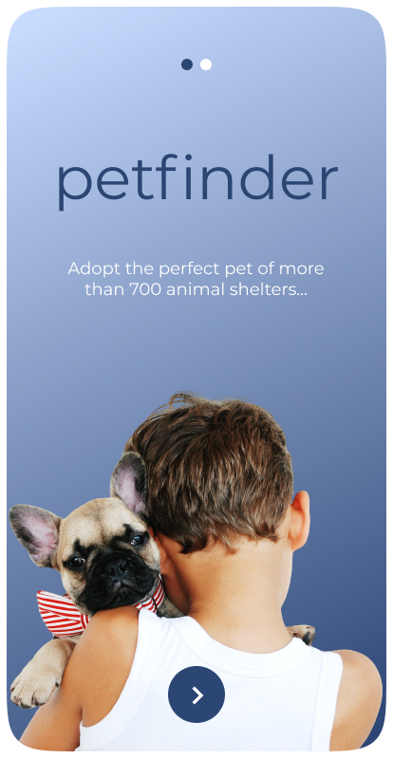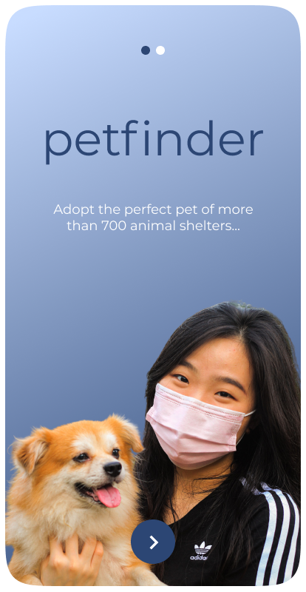

**Search**

The user will be able to search through a text field, they will also be able to switch between the categories dogs and cats, and in the case of clicking on a pet they will be able to view their complete data.

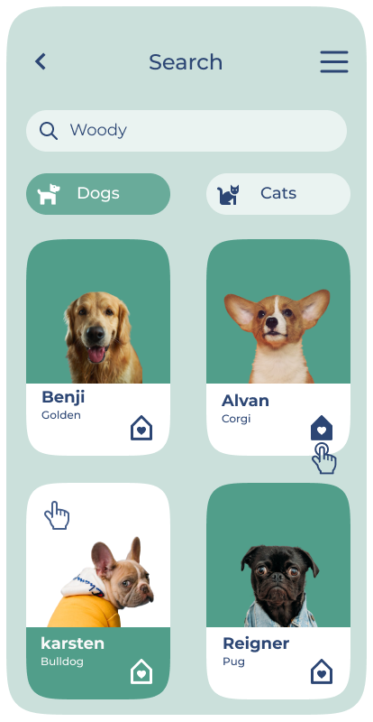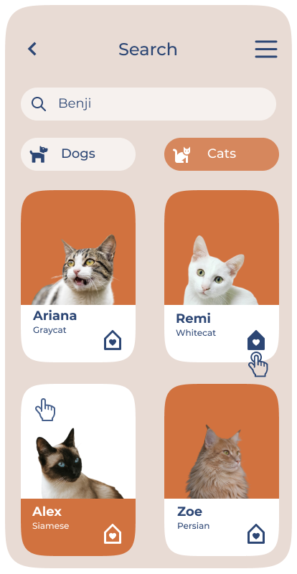

**Burger Menu**

The user will be able to see a superimposed menu by pressing the hamburger menu and will have the possibility of going through different sections.

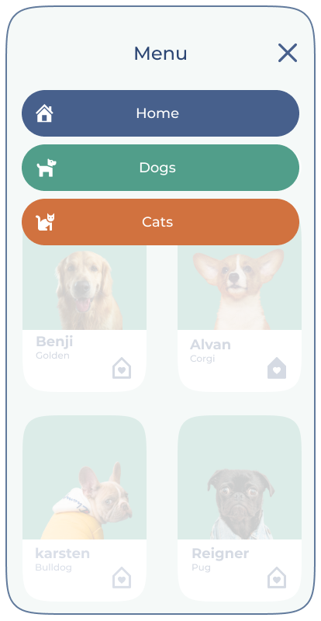

**Preview**

The user will be able to see the characteristics of the pet and, if necessary, take it home.

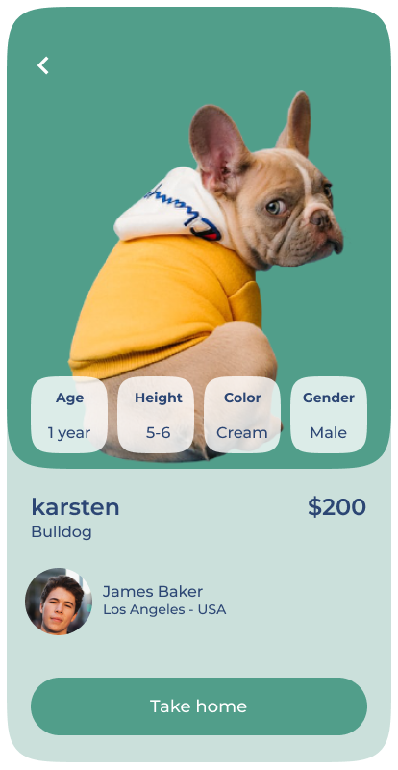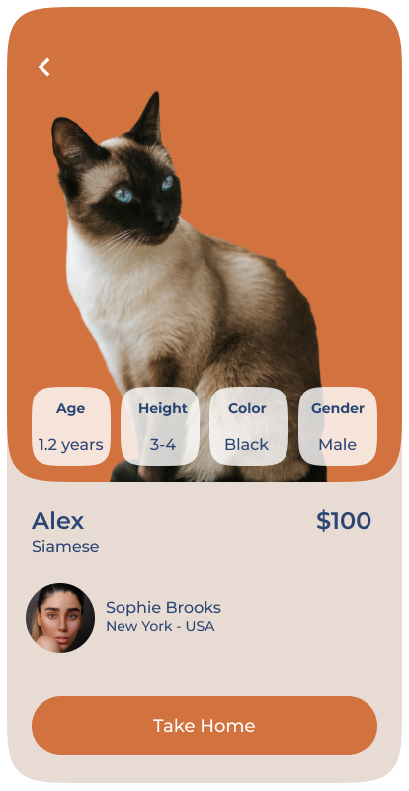

**INSTRUCTIONS FOR THE COMPETITOR**

Follow the instructions below to submit your work.

1. The multimedia resources are available in the compressed file "03-layout.zip". You can modify the supplied files and create new multimedia files to guarantee their correct functionality and achieve a layout that is as close to the designs and prototypes.
2. Save and work the layout in a directory on the desktop called "XX-module03". Make sure your main file is named index.html.
3. Make sure your site can be started when the address is accessed  
   http://<dominio>/XX_module03

* XX is your country code.